*TP Orange Data Mining*

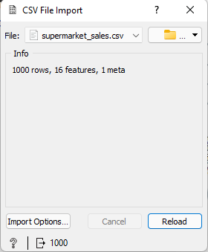

Load the DataSet “supermarket_sales.csv”

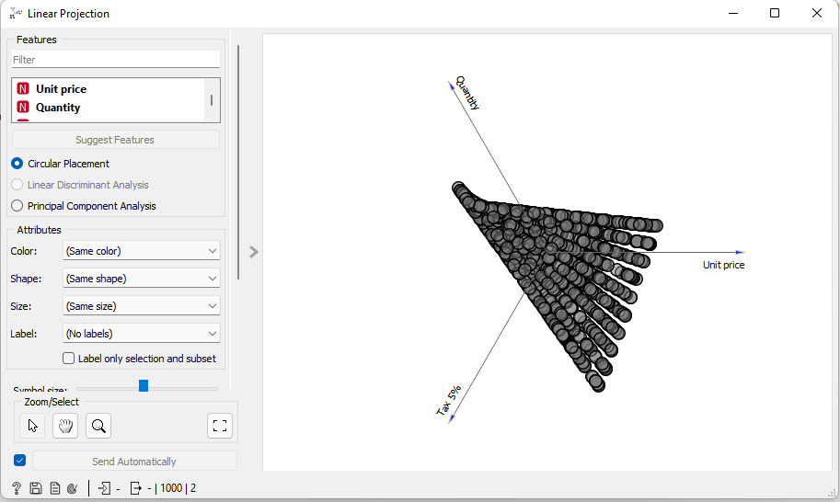

Check for outliers with Liner Projection

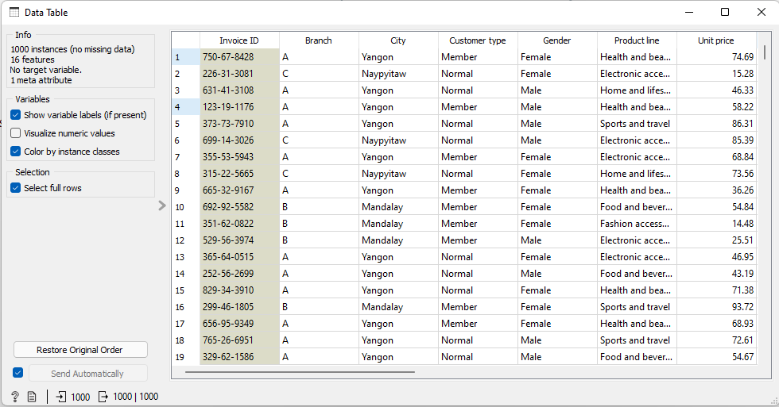Show data with Data table

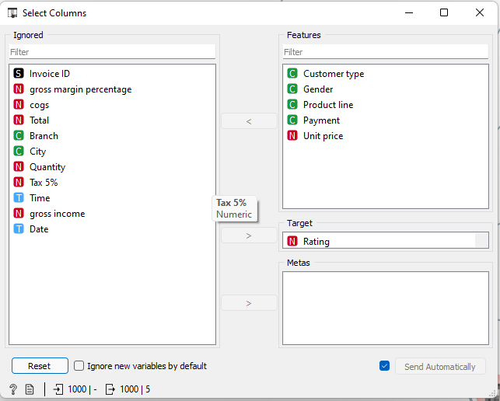

Ignore useful column and select Rating as a target class

The feature Date is very important in Sales DataSets but i decide to ignore it because i did not knew how to extract only months and days from the date

We can use months and days to know what is the best day of the week for selling , same for months and even time per day

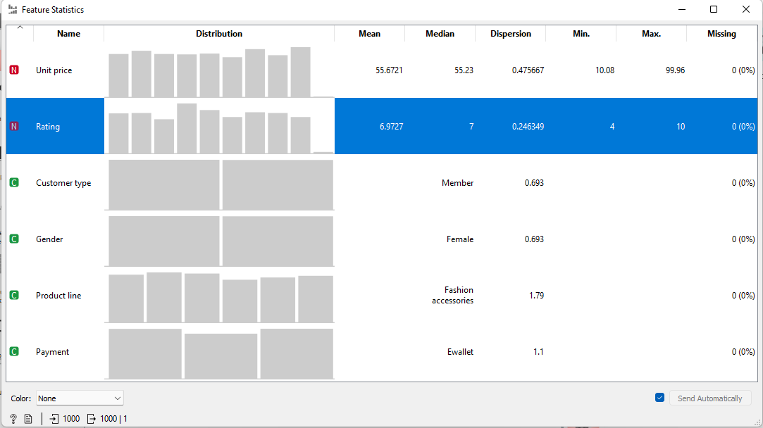Display feature description

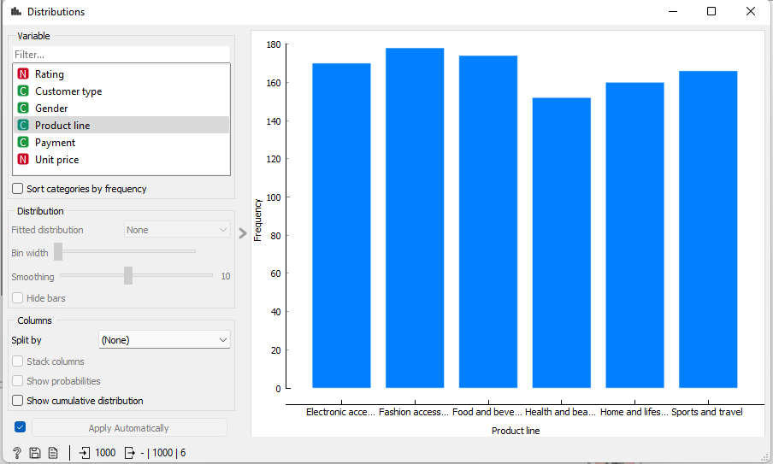Display the frequency of data per feature

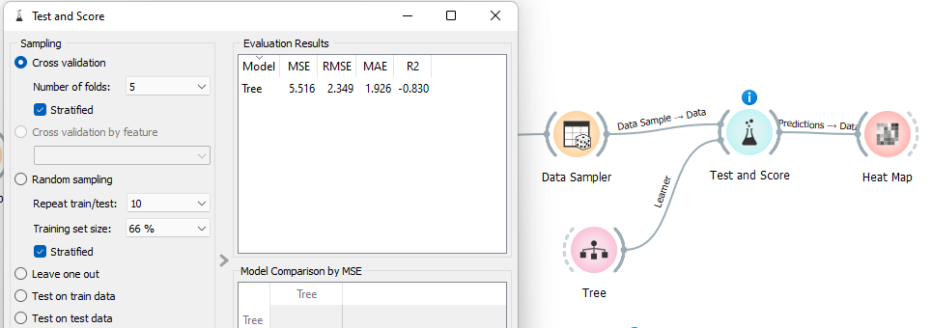Use Decision Tree algorithm

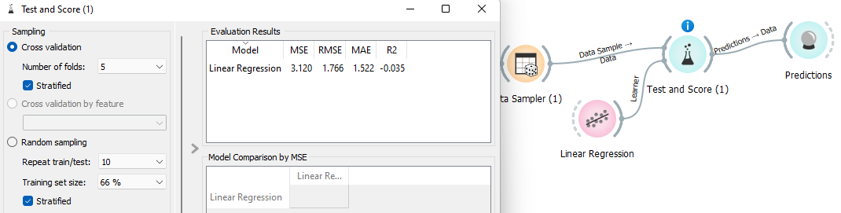Use Linear Regression algorithm